Name: Maloth Aditya
Roll No.: 120CS0124

SCCS – Software Component Cataloguing Software

Sequence Diagram for SCCS
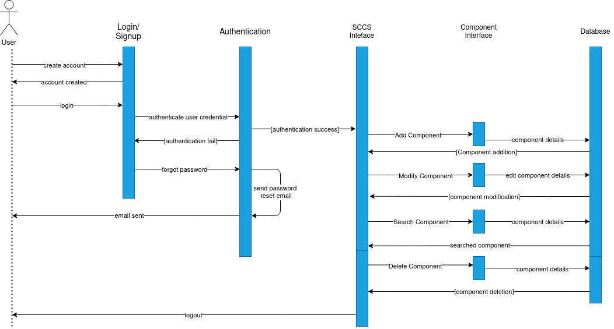

Collaboration Diagram for SCCS
